Math Fact Fluency Background:
- Foundational Fact Strategy Game for Addition
- Doubles Bingo provides additional experiences with doubling a number.
- Ease of mastery, combined with the observation that more difficult facts (such as 7 + 8) are close to doubles facts, make the doubles a particularly useful group of foundational facts to learn.
- Teachers can harness the potential of naturally occurring doubles to provide context and a backdrop to introduce the term doubles fact.
- Once doubles facts have been formally identified, substantial and enjoyable practice, such as Doubles Bingo, will be needed to ensure student mastery.
About Games and Math Fact Fluency:
Games are fun. But, more importantly, games are effective ways to support learning. Games provide opportunities for:
- low-stress practice of (1) facts and (2) strategies (both outcomes are critical to math beyond the basic facts!).
- think aloud, an effective learning strategy. Therefore, students should develop the habit of verbalizing their mathematical thinking out loud.
- student listening and learning from peers. Therefore, discussing strategies before and after playing allows students opportunities to learn from each other.
- teachers to formatively assess and plan instruction. Therefore, at times, use an observation tool to record how students are progressing.
Effective math fact fluency games remove time pressure and allow students time to think. That means no time component. Each player has their own cards or dice to roll, so they are not racing each other. Scoring is de-emphasized. Thinking strategies are front and center.
Doubles Bingo 2 players
Materials: one blank 4 x 4 bingo card per student, 16 bingo chips per student, one deck of cards with kings and jacks removed (ace= 1, queen = 0)

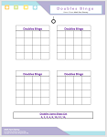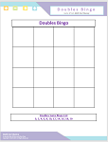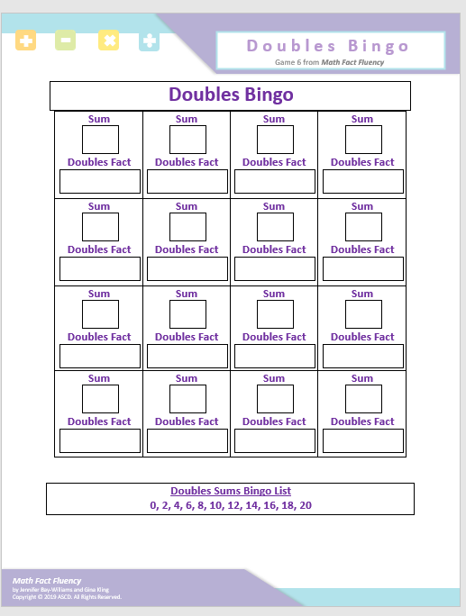

Multiple Rounds/ Partner Whole Group Whole Group with Recording Option

Doubles Bingo 2 players
How to Play:
- Provide a list of the doubles sums: 0, 2, 4, 6, 8, 10, 12, 14, 16, 18, and 20.
- Each student fills in a blank 4 x 4 bingo card using the numbers from the doubles sum list.
Each students’ bingo card will be different. Some sums will need to be repeated, and not all sums must be used. Options: Whole class bingo card, 4 multiple rounds/ partners Bingo Card, Bingo Card with option to record the doubles equation.
- The teacher draws a card from the deck.
- Students must use that card to make an addition doubles fact.
- Students cover the doubles sum on their bingo cards.
For Example: If a four is drawn, students find the answer to 4 + 4 and cover the doubles sum (8) on their cards.
- Only one space can be covered on each turn.
- Students cannot move a bingo chip after it has been placed.
- Four chips in a row (horizontally, diagonally, or vertically) results in a bingo.
Example of a completed student game board. The teacher has drawn a four and the student has marked the doubles fact sum 8.

Game in Action:

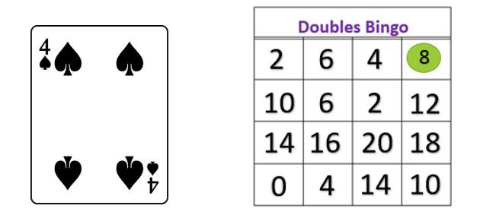
Possible Variations:
- Use a 5 x 5 bingo card. Adapt the game to any fact set by simply giving the students the list of possible sums. For example, students can play Two Less Bingo to practice the -2 facts, using a card deck with only 2-10 and a bingo card with the numbers 0-8.

